

**CS251 –Software Engineering I**

**Course name:** Software engineering1 (CS 251)

**Professor:** Dr. Mohamed El-Ramly

**TA:**Youmna Magdy

**Project name:** Books Networking

**Leader name:** Nabila SamyFathy

**Leader contact:** nabila.samy94@yahoo.com

Contents

Team 3

Document Purpose and Audience 3

System Models 3

System Decomposition 3

Class diagrams 4

Sequence diagrams 5

Class - Sequence Usage 6

Physical Entity-Relationship Diagram 10

User Interface Design 11

Screen 1 – login 11

Screen 2 – signup 11

Screen 3 – User home page 12

Screen 4 – Book Option 12

Ownership Report 13

# Team

|  |  |  |  |
| --- | --- | --- | --- |
| **ID** | **Name** | **Email** | **Mobile** |
| 20120417 | Nabila SamyFathy | Nabila.samy94@yahoo.com | 01116784387 |
| 20120408 | Mai Mohamed Ismail | Mai.m7md95@yahoo.com | 01096311628 |
| 20120445 | HodaTawakl El-Sayed | hodatawakl@yahoo.com | 01007191713 |
| 20120484 | Hadeer Mohamed Hassan | hadeermuhamad10000@gmail.com | 01110372897 |

# Document Purpose and Audience

# This document explains the process inside book network system. It describes the interfaces of the system and what the system will do and the constraints. The purpose is to explain to the stack holders how to interact and use BNS.

* The Audience: clerk/admin, books network's users.

# 

# System Models

## System Decomposition

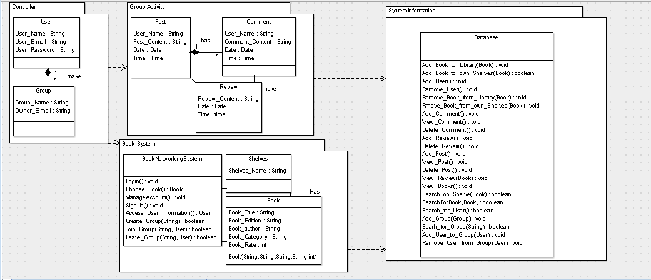

## Class diagrams

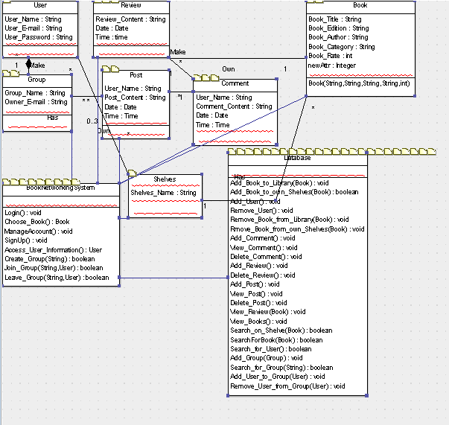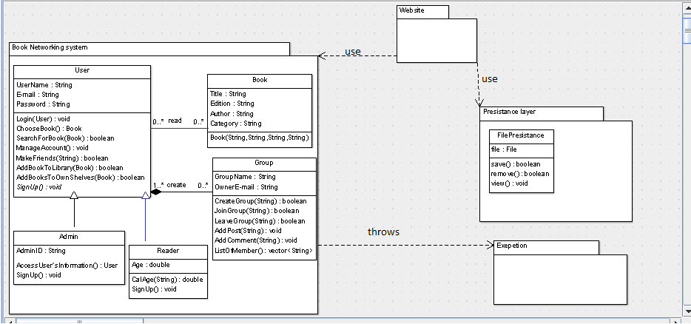

| **Class ID** | **Class Name** | **Subsystem ID** | **Description** |
| --- | --- | --- | --- |
| 1 | User | 1 | Class represents general attributes & methods that website user can do. |
| 2 | Admin | 1 | Class represents attributes & methods that admin can do. |
| 3 | Reader | 1 | Class represents attributes & methods that reader can do. |
| 4 | Book | 1 | Class represents attributes & methods related to books in the site. |
| 5 | Group | 1 | Class represents attributes & methods of groups in the site. |
| 6 | FilePersistence | 2 | Class represents how we store data in files. |

## 

## Sequence diagrams

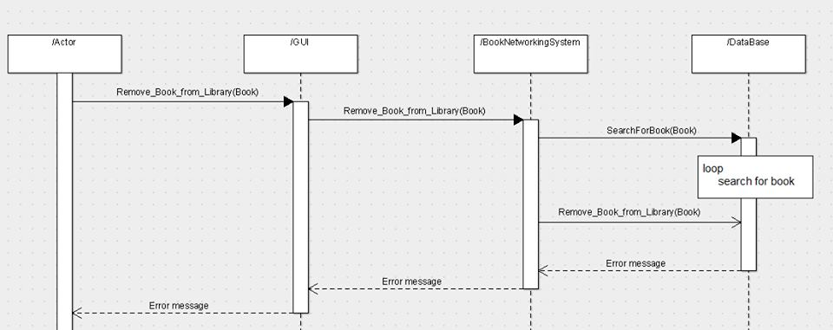

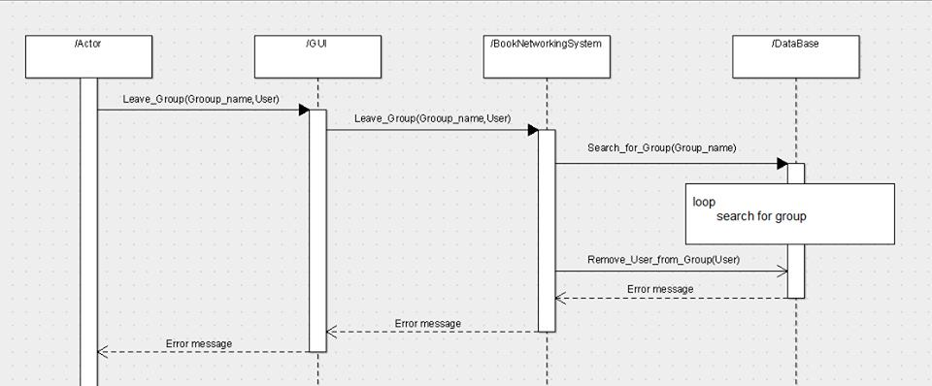

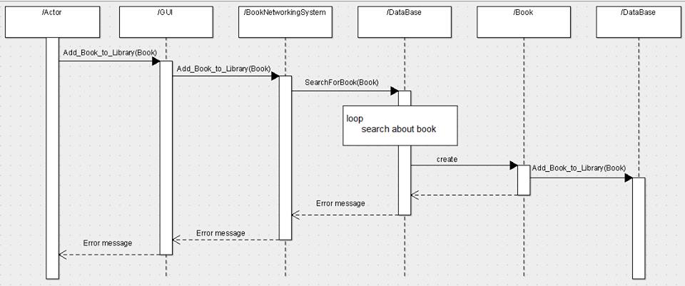

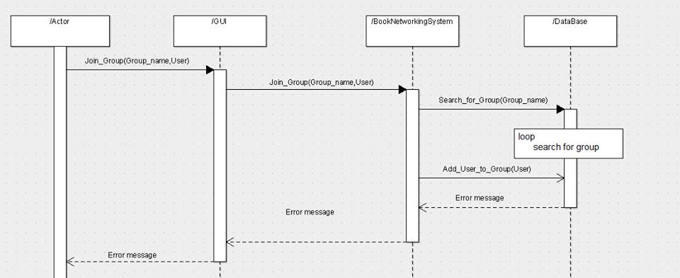

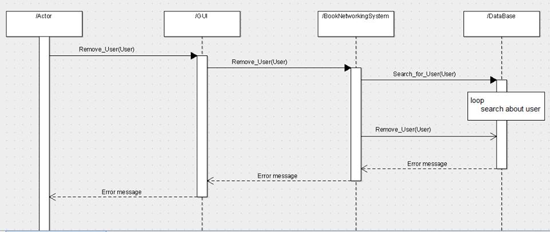

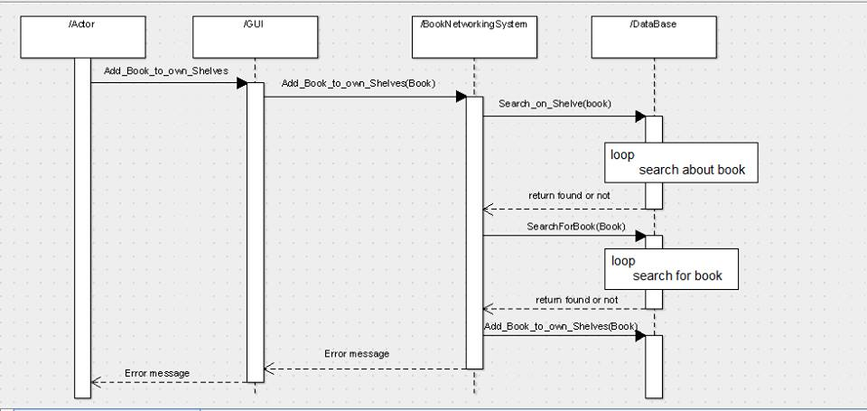

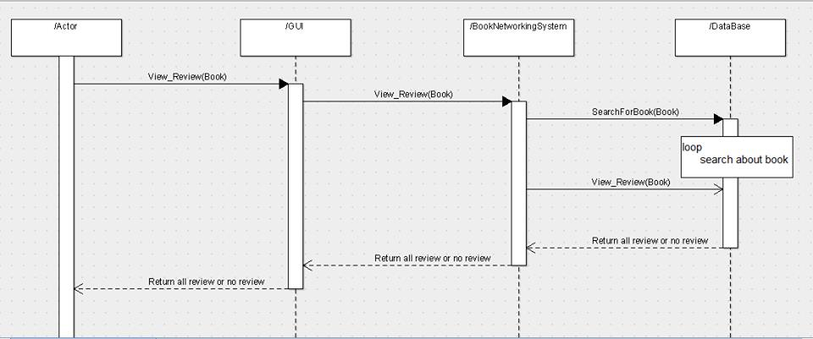

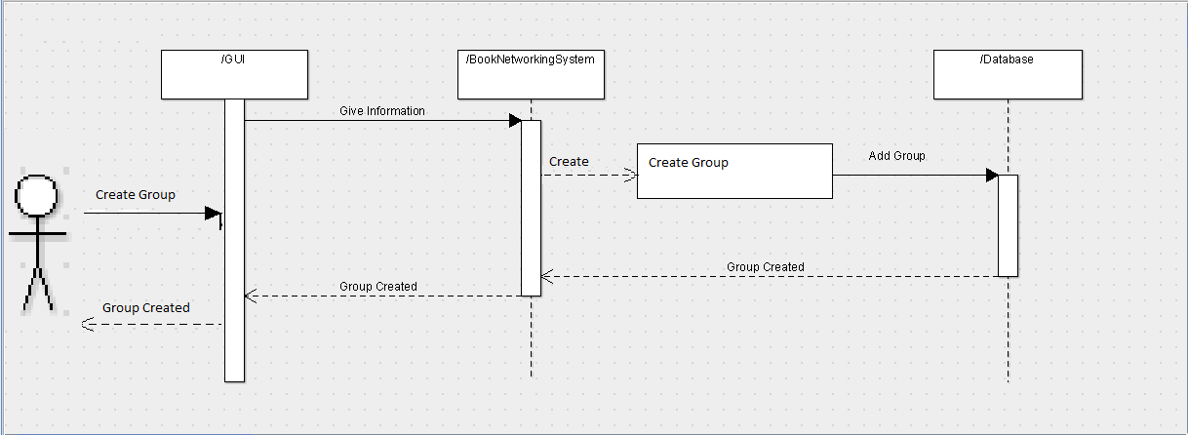

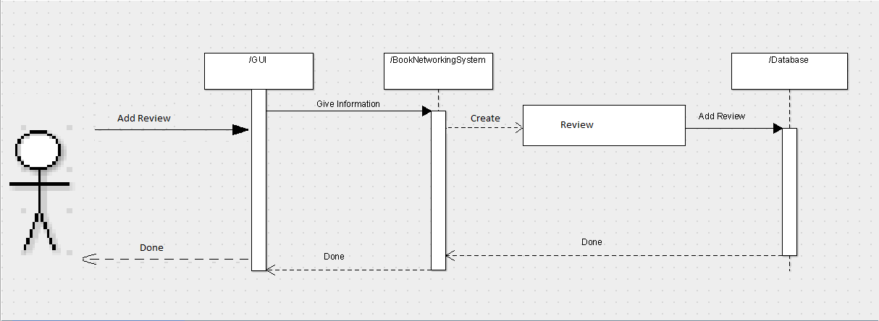

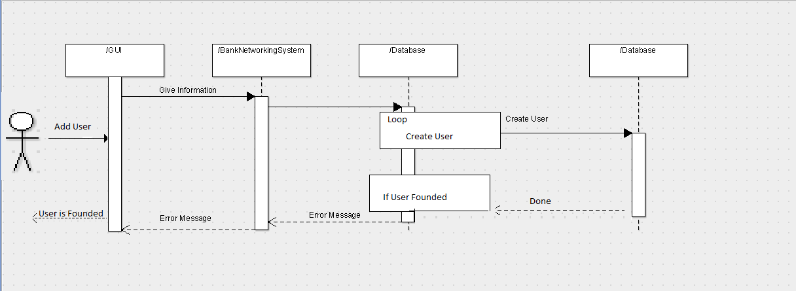

## Physical Entity-Relationship Diagram

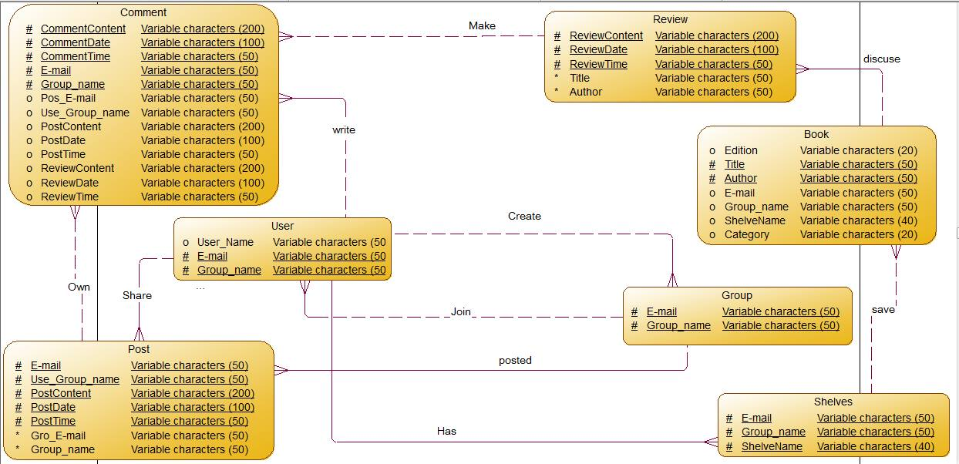

## 

## User Interface Design

### Screen 1 – login

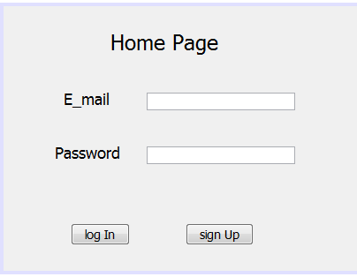

### Screen 2 – signup

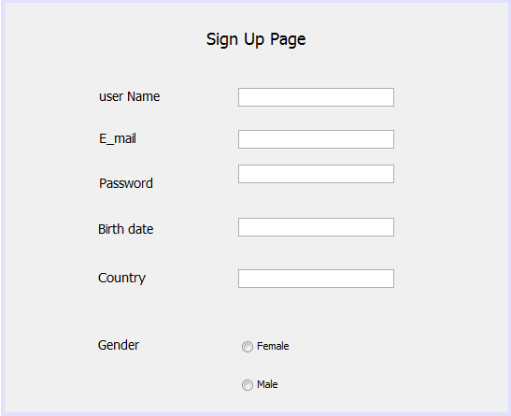

### Screen 3 – User home page

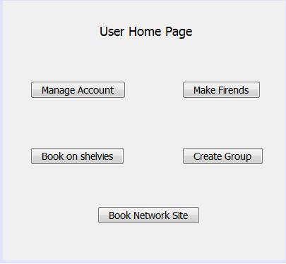

### Screen 4 – Book Option

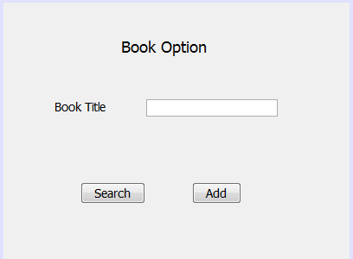

# Ownership Report

|  |  |
| --- | --- |
| **Item** | **Owners** |
| Document Purpose and Audience | Nabila Samy Fathy |
| System Decomposition | Hadeer Mohamed Hassan |
| Class diagrams | Nabila Samy Fathy |
| Sequence diagrams | Hoda Tawakl El-Sayed |
| Class - Sequence Usage | Mai Mohamed Ismail |
| Physical Entity-Relationship Diagram | Mai Mohamed Ismail |
| User Interface Design | Hoda Tawakl El-Sayed |